CFA of PIA variables
I estimated a confirmatory factor analysis model with three factors, reflecting our theoretical expectation that populism, illiberalism and authoritarianism constitute distinct (but correlated) latent variables. The model took account of the ordinal character of the data, and applied sampling weights.

Full model
The full model, containing six populism variables, 14 illiberalism variables, and five authoritarianism variables, is a poor fit to the data, with an RMSEA of 0.112. The variables with the weakest loadings are highlighted in red below.
Estimate Std.Err z-value P(>|z|)
pop =~
P2_02 0.263 0.017 15.293 0.000
P2_03 0.264 0.018 14.881 0.000
P11_04r 0.513 0.017 29.827 0.000
P11_05r 0.693 0.018 37.627 0.000
P11_06r 0.491 0.016 31.061 0.000
P11_07r 0.536 0.016 32.825 0.000
illib =~
P2_04r 0.201 0.015 13.641 0.000
P2_06r 0.216 0.017 12.968 0.000
P4_03r 0.520 0.012 42.033 0.000
P4_04r 0.625 0.011 56.170 0.000
P4_05 0.272 0.016 17.239 0.000
P4_06r 0.627 0.011 55.452 0.000
P4_07r 0.508 0.013 39.739 0.000
P4_08r 0.506 0.014 36.095 0.000
P11_08r 0.377 0.014 26.776 0.000
P12_01r 0.774 0.008 93.602 0.000
P12_02r 0.669 0.010 64.805 0.000
P12_03r 0.540 0.012 45.328 0.000
P12_04r 0.633 0.011 58.230 0.000
P12_05r 0.667 0.010 68.864 0.000
aut =~
P2_10 0.331 0.016 21.083 0.000
P2_11 0.416 0.016 25.248 0.000
P3 0.623 0.016 40.024 0.000
P4_01r 0.660 0.015 43.773 0.000
P4_02r 0.499 0.017 29.385 0.000

When the poorly performing variables are removed, the model fit improves somewhat, but is still mediocre, with an RMSEA of 0.086.
Latent Variables:
Estimate Std.Err z-value P(>|z|)
pop_short =~
P11_04r 0.482 0.016 29.740 0.000
P11_05r 0.648 0.017 38.069 0.000
P11_06r 0.423 0.016 27.128 0.000
P11_07r 0.470 0.016 29.234 0.000
illib_short =~
P4_03r 0.511 0.012 41.432 0.000
P4_04r 0.607 0.011 52.901 0.000
P4_06r 0.613 0.011 53.368 0.000
P4_07r 0.519 0.013 41.340 0.000
P4_08r 0.481 0.014 33.896 0.000
P11_08r 0.370 0.014 26.459 0.000
P12_01r 0.775 0.008 94.862 0.000
P12_02r 0.675 0.010 66.242 0.000
P12_03r 0.544 0.012 46.266 0.000
P12_04r 0.627 0.011 58.439 0.000
P12_05r 0.667 0.010 70.035 0.000
aut_short =~
P2_11 0.339 0.017 20.036 0.000
P3 0.559 0.016 35.025 0.000
P4_01r 0.614 0.015 40.401 0.000
P4_02r 0.508 0.017 30.556 0.000

I extracted three factors from the shorter version. There are strong correlations between all factors, with illiberalism correlating more strongly than authoritarianism with populism.
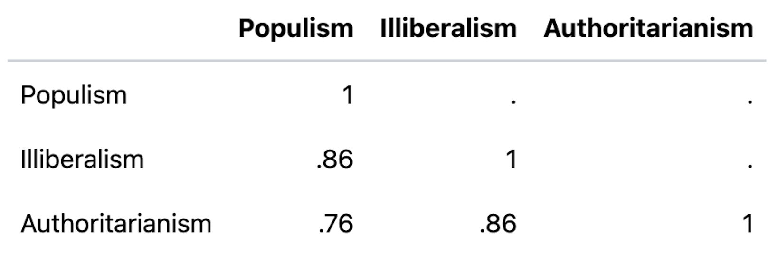

Poland
This has a worse fit than the full model (RMSEA=0.109), perhaps due to a couple of low loadings (highlighted in red).
Estimate Std.Err z-value P(>|z|)
pop_short_PL =~
P11_04r 0.455 0.035 12.895 0.000
P11_05r 0.659 0.031 21.002 0.000
P11_06r 0.585 0.032 18.372 0.000
P11_07r 0.413 0.039 10.520 0.000
illib_short_PL =~
P4_03r 0.570 0.027 21.395 0.000
P4_04r 0.687 0.024 29.020 0.000
P4_06r 0.719 0.021 33.472 0.000
P4_07r 0.479 0.030 15.948 0.000
P4_08r 0.571 0.031 18.266 0.000
P11_08r 0.312 0.033 9.439 0.000
P12_01r 0.816 0.016 50.191 0.000
P12_02r 0.668 0.025 27.105 0.000
P12_03r 0.676 0.023 28.925 0.000
P12_04r 0.693 0.023 30.722 0.000
P12_05r 0.691 0.022 31.649 0.000
aut_short_PL =~
P2_11 0.372 0.041 9.063 0.000
P3 0.420 0.042 9.961 0.000
P4_01r 0.732 0.036 20.271 0.000
P4_02r 0.404 0.041 9.781 0.000

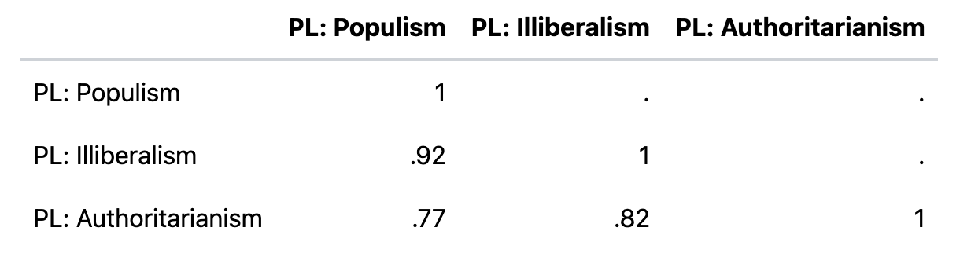
Using bivariate multinomial regression, I regressed vote share on each of these variables in turn. The results are consistent with what I would intuitively expect, with lower levels of the PIA variables associated with a higher probability of voting for KO and Lewica, and higher levels of PIA variables associated with a higher probability of voting for PiS and Konfederacja.

Great Britain
RMSEA=0.084

Estimate Std.Err z-value P(>|z|)
pop_short_GB =~
P11_04r 0.440 0.046 9.489 0.000
P11_05r 0.696 0.055 12.739 0.000
P11_06r 0.357 0.046 7.819 0.000
P11_07r 0.280 0.048 5.874 0.000
illib_short_GB =~
P4_03r 0.549 0.036 15.441 0.000
P4_04r 0.602 0.035 17.314 0.000
P4_06r 0.615 0.035 17.686 0.000
P4_07r 0.585 0.036 16.154 0.000
P4_08r 0.541 0.040 13.371 0.000
P11_08r 0.401 0.040 9.987 0.000
P12_01r 0.725 0.029 24.641 0.000
P12_02r 0.659 0.031 21.492 0.000
P12_03r 0.507 0.039 13.092 0.000
P12_04r 0.525 0.037 14.333 0.000
P12_05r 0.619 0.031 19.810 0.000
aut_short_GB =~
P2_11 0.346 0.046 7.455 0.000
P3 0.456 0.050 9.062 0.000
P4_01r 0.650 0.044 14.767 0.000
P4_02r 0.577 0.044 13.090 0.000

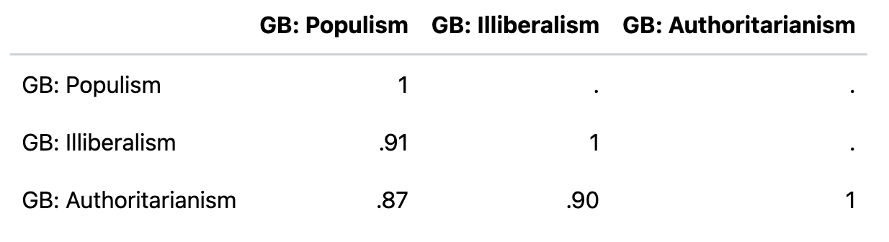

Czechia
RMSEA=0.087
Estimate Std.Err z-value P(>|z|)
pop_short_CZ =~
P11_04r 0.368 0.035 10.512 0.000
P11_05r 0.595 0.032 18.494 0.000
P11_06r 0.705 0.028 25.503 0.000
P11_07r 0.684 0.028 24.319 0.000
illib_short_CZ =~
P4_03r 0.355 0.036 9.840 0.000
P4_04r 0.537 0.031 17.160 0.000
P4_06r 0.591 0.028 21.061 0.000
P4_07r 0.602 0.027 22.247 0.000
P4_08r 0.187 0.044 4.290 0.000
P11_08r 0.149 0.037 4.032 0.000
P12_01r 0.790 0.018 44.537 0.000
P12_02r 0.716 0.023 31.327 0.000
P12_03r 0.568 0.028 20.017 0.000
P12_04r 0.605 0.027 22.688 0.000
P12_05r 0.594 0.026 22.694 0.000
aut_short_CZ =~
P2_11 0.080 0.052 1.535 0.125
P3 0.544 0.044 12.355 0.000
P4_01r 0.542 0.043 12.535 0.000
P4_02r 0.447 0.046 9.764 0.000

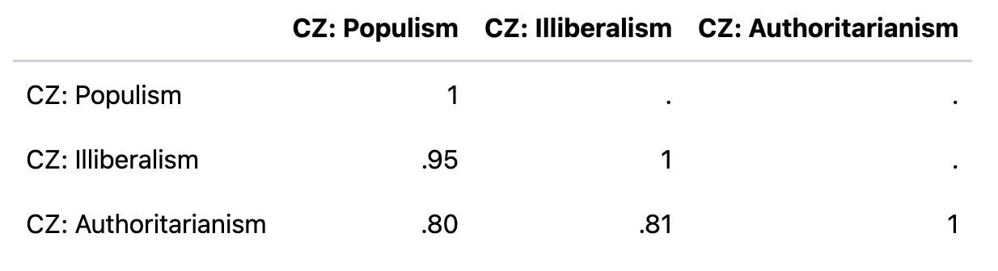

France
RMSEA=0.107
Estimate Std.Err z-value P(>|z|)
pop_short_FR =~
P11_04r 0.320 0.052 6.190 0.000
P11_05r 0.380 0.050 7.583 0.000
P11_06r 0.620 0.037 16.734 0.000
P11_07r 0.759 0.038 20.024 0.000
illib_short_FR =~
P4_03r 0.606 0.031 19.469 0.000
P4_04r 0.565 0.037 15.468 0.000
P4_06r 0.483 0.039 12.279 0.000
P4_07r 0.645 0.035 18.612 0.000
P4_08r 0.501 0.045 11.260 0.000
P11_08r 0.388 0.046 8.518 0.000
P12_01r 0.717 0.027 26.582 0.000
P12_02r 0.563 0.032 17.407 0.000
P12_03r 0.450 0.036 12.595 0.000
P12_04r 0.483 0.037 13.191 0.000
P12_05r 0.689 0.026 26.088 0.000
aut_short_FR =~
P2_11 0.335 0.047 7.115 0.000
P3 0.432 0.044 9.904 0.000
P4_01r 0.715 0.033 21.837 0.000
P4_02r 0.695 0.038 18.508 0.000

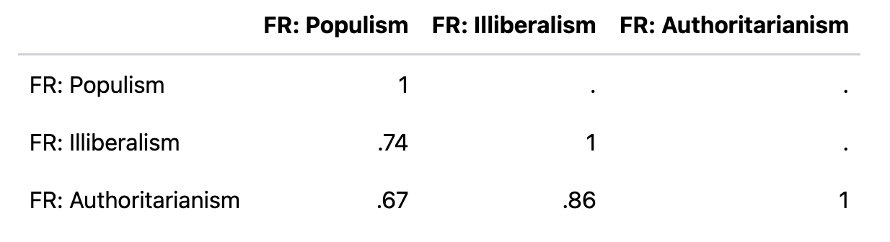

Hungary
RMSEA=0.078
It should be noted that in the Hungarian case two of the populism items do not work, to the extent that it was necessary to remove them to make the model fit at all. These two items are “Hungary is pretty much run by a few big interests looking out for themselves” and “Politicians constantly overcomplicate matters instead of effectively solving them”. The likely reason that these do not load well is because Hungary is a long-standing populist incumbent, and these items are worded in an “anti-incumbent” manner. This is a broader problem with populist question batteries, which often struggle to operationalise the elite in a way which is distinct from “the current incumbent”.
Estimate Std.Err z-value P(>|z|)
pop_short_HU =~
P11_04r 0.479 0.039 12.407 0.000
P11_05r 0.511 0.039 13.176 0.000
illib_short_HU =~
P4_03r 0.462 0.028 16.742 0.000
P4_04r 0.676 0.020 33.621 0.000
P4_06r 0.748 0.019 39.836 0.000
P4_07r 0.246 0.033 7.419 0.000
P4_08r 0.545 0.027 20.420 0.000
P11_08r 0.538 0.025 21.425 0.000
P12_01r 0.823 0.013 61.908 0.000
P12_02r 0.632 0.022 28.247 0.000
P12_03r 0.721 0.018 38.980 0.000
P12_04r 0.777 0.016 48.635 0.000
P12_05r 0.678 0.020 33.760 0.000
aut_short_HU =~
P2_11 0.474 0.033 14.472 0.000
P3 0.702 0.026 26.788 0.000
P4_01r 0.668 0.028 23.801 0.000
P4_02r 0.387 0.037 10.593 0.000

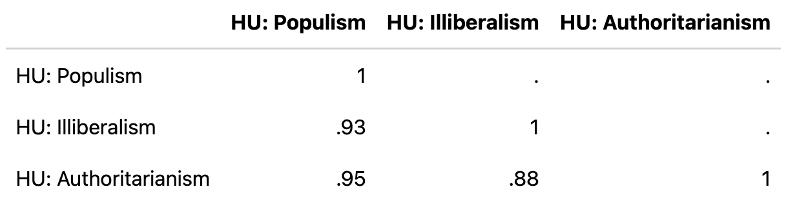

Italy
RMSEA=0.088
Estimate Std.Err z-value P(>|z|)
pop_short_IT =~
P11_04r 0.457 0.041 11.133 0.000
P11_05r 0.588 0.045 13.177 0.000
P11_06r 0.299 0.041 7.219 0.000
P11_07r 0.268 0.043 6.231 0.000
illib_short_IT =~
P4_03r 0.543 0.037 14.833 0.000
P4_04r 0.572 0.033 17.290 0.000
P4_06r 0.465 0.038 12.224 0.000
P4_07r 0.470 0.037 12.713 0.000
P4_08r 0.467 0.037 12.549 0.000
P11_08r 0.502 0.033 15.036 0.000
P12_01r 0.785 0.021 37.380 0.000
P12_02r 0.716 0.026 27.471 0.000
P12_03r 0.465 0.035 13.332 0.000
P12_04r 0.607 0.030 20.147 0.000
P12_05r 0.613 0.027 22.412 0.000
aut_short_IT =~
P2_11 0.196 0.046 4.281 0.000
P3 0.571 0.042 13.531 0.000
P4_01r 0.418 0.048 8.760 0.000
P4_02r 0.524 0.046 11.353 0.000

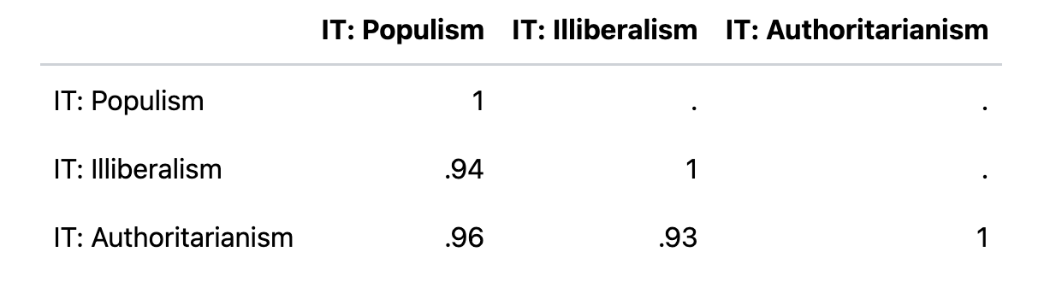

Austria
RMSEA=0.091
Estimate Std.Err z-value P(>|z|)
pop_short_AT =~
P11_04r 0.563 0.033 16.925 0.000
P11_05r 0.704 0.031 23.023 0.000
P11_06r 0.485 0.035 13.687 0.000
P11_07r 0.626 0.031 20.350 0.000
illib_short_AT =~
P4_03r 0.541 0.028 19.015 0.000
P4_04r 0.646 0.026 24.536 0.000
P4_06r 0.729 0.021 34.196 0.000
P4_07r 0.701 0.022 31.500 0.000
P4_08r 0.504 0.035 14.240 0.000
P11_08r 0.481 0.030 15.985 0.000
P12_01r 0.808 0.017 47.038 0.000
P12_02r 0.734 0.021 34.606 0.000
P12_03r 0.494 0.030 16.714 0.000
P12_04r 0.651 0.026 24.892 0.000
P12_05r 0.725 0.021 34.391 0.000
aut_short_AT =~
P2_11 0.389 0.035 11.206 0.000
P3 0.621 0.032 19.403 0.000
P4_01r 0.641 0.032 19.930 0.000
P4_02r 0.616 0.035 17.560 0.000

